
Politecnico di Milano – V Facoltà di Ingegneria

075274 e 070644 - Sistemi distribuiti (con laboratorio)
Prof. G. Cugola

Appello del 1 Settembre 2010
Rules:
- You are not allowed to use books, notes, or other material.
- You can answer in Italian or English.
- Total time for the test: 2 hours.

- Implement in Java an Executor. At creation time it takes a Runnable as a parameter and, after being started (see below), it invokes the run method repeatedly. The Executor provides four methods. A method start to start invoking the run method of the Runnable passed at creation time, a method suspend to suspend running (after the current cycle of run has completed), a method continue to continue after suspending, and a method stop to finally halt execution (again, after the current cycle of run has completed).

- Describe the REST architectural style and its “CREST” variation.

- Describe how scalar clocks can be used to guarantee mutual exclusion in accessing a resource.

- Si consideri il sistema in figura sul quale è in corso un distributed snapshot. Si supponga che ogni processo operi sommando il valore dei messaggi ricevuti al valore intero S che rappresenta il proprio stato. Il processo A ha dato inizio allo snapshot mandando un token (già consumato) al processo B.

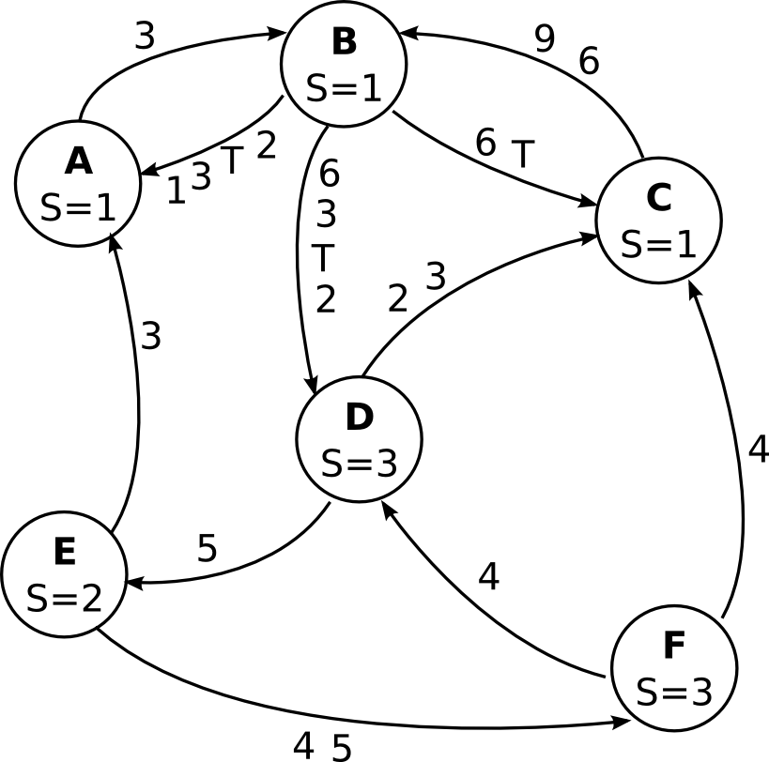

Assumendo che non vi siano altre operazioni nel sistema oltre quelle necessarie a completare lo snapshot e che i canali uscenti da B siano molto più veloce di tutti gli altri canali, si mostri lo stato (stato locale e messaggi per ogni link) registrato da ogni nodo a fine snapshot.

- Describe pessimistic timestamp ordering to control concurrency in distributed transactions (i.e., to guarantee serializability).

- Consider the following processes (A, B, C), running concurrently and acting on variables x, y, z. Assume the following initial values: x = 0; y = 0; z = null.

Process A | Process B | Process C
x = 1;  if (y==0) {  z = ‘A’;  } | y = 1;  if (x==0) {  z = ‘B’;  } | Print z;  Print x;  Print y;

Complete the following table, showing which sets of values represent a valid output for process C when using a sequential, causal, or FIFO consistency model.
Motivate your answers.

z | x | y | Seq | Causal | FIFO
A | 0 | 0
B | 0 | 0
A | 0 | 1
B | 0 | 1
A | 1 | 0
B | 1 | 0
A | 1 | 1
B | 1 | 1

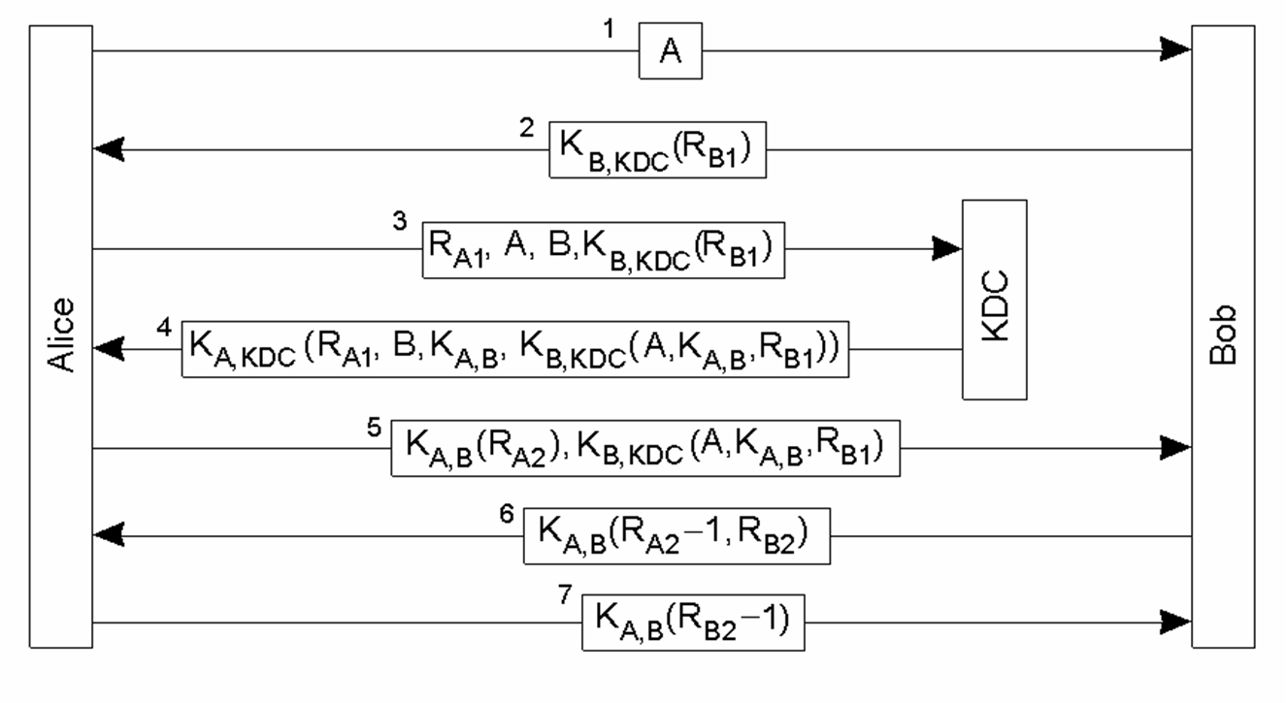
Consider the protocol shown in Figure above:

- Describe the general aim of the protocol and briefly explain the meaning of each message.
- Why does Alice need to contact Bob before starting the communication with the KDC?
- Why does message 4 contains both R_{A1} and B?

